About Finn Hill
Located in northwest Kirkland and bordered by Kenmore to the north, Finn Hill is the City’s largest neighborhood geographically (2600 acres), its second most populous (approximately 16,000 residents) and its most environmentally diverse: Finn Hill features deep ravines, multiple watersheds and wetlands, a variety of parks and woodlands, and an extensive lakeshore.
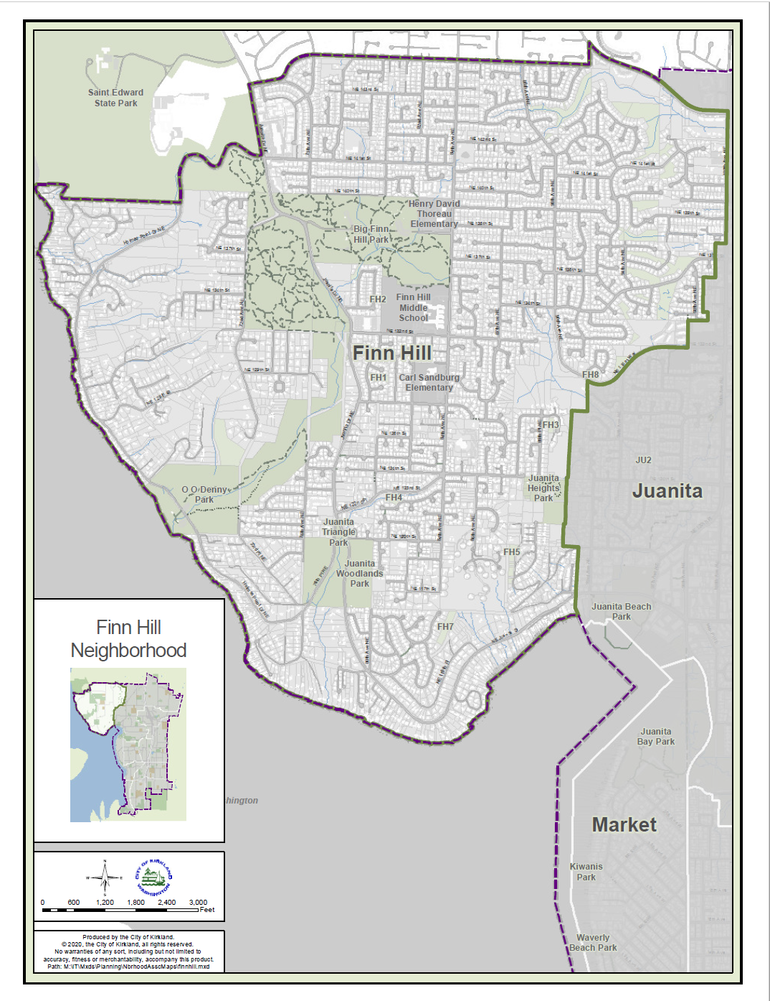
The Finn Hill chapter of the Kirkland Comprehensive Plan describes our neighborhood and its residents as follows:
Finn Hill is a predominantly residential, heavily treed and picturesque neighborhood overlooking Lake Washington. Rising to a height of 535 feet above sea level, with ravines and steep slopes on its flanks, Finn Hill is bounded by Lake Washington to the south and west, NE 145th Street to the north, and the Juanita Neighborhood to the east. Access to the neighborhood is limited to three main entry points: Juanita Drive provides access to the southern and western portions of the hill, and Simonds Road/NE 145th Street and NE 132nd/90th Streets provide the northern east/west access to Finn Hill.
…..
Finn Hill residents feel very strongly about the unique setting of their neighborhood. Parks and natural areas are the stars of Finn Hill and are considered high-value resources that provide important wildlife and recreation connections. There is a deep affinity with, and a desire to care for, the natural environment, parks, open space, tree canopy, and Lake Washington. Residents take pride in their history of participating in fundraising campaigns, work parties, and planning activities focused on protecting the neighborhood’s woodlands, streams and parks. Preserving or improving natural open space connectivity wherever possible is a major goal for Finn Hill residents, and received overwhelming support through the public outreach process.
Finn Hill’s human history
The great Corderillan ice sheet that covered the Puget Sound for millenia slowly began to retreat about 18,000 years ago, leaving behind the Puget Sound, freshwater lakes, and drumlins, including Finn Hill. Thereafter, Finn Hill’s streams and shores served as fishing grounds for the indigenous Salish Peoples. Prior to European settlement, the hill was dominated by Douglas fir, hemlock and western red cedar.
The mouth of Juanita Creek (today’s Juanita Beach Park), just south and west of Finn Hill, was home to a settlement of the Duwamish tribe called TUHB-tuh-byookw, one of several Duwamish settlements along what is now Kirkland’s lakeshore. These settlements were abandoned after the Duwamish ceded 54,000 acres of land under the 1855 Treat of Point Elliot.
Early European settlers of Finn Hill were predominantly of Finnish descent. The first families settled in 1896; some of the 55 families in the area include the Reinikainen (later changed to Raine), Norman, Mielonen, Peltonen, Lindquist, Jarvi, Salmonson, and Haapa families. Families shared 29 saunas (one of which can be found at the Nordic Heritage Museum in Seattle). At one time there were three halls for community dances, plays, and other programs.
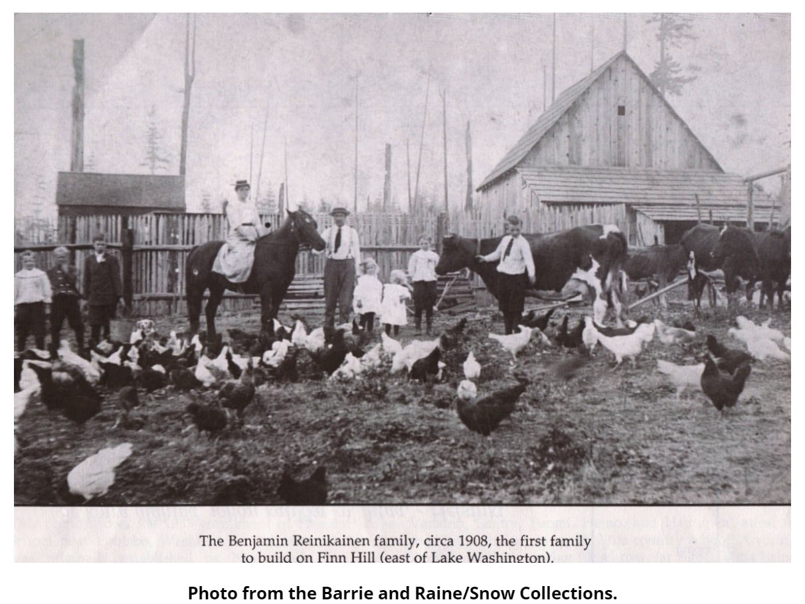
As elsewhere in Kirkland, these early settlers first logged the area, then burned and pulled out the massive stumps left behind to prepare the land for agriculture. The Woodins Logging Co. built a tramway in the ravine next to Goodwill Hill to take the logs from the top of the hill to Juanita Bay. A dock – Hubbards Landing -- was constructed near the current site of Michaels at 98th and 116th for loading timber on cargo ships. It later became a ferry stop.

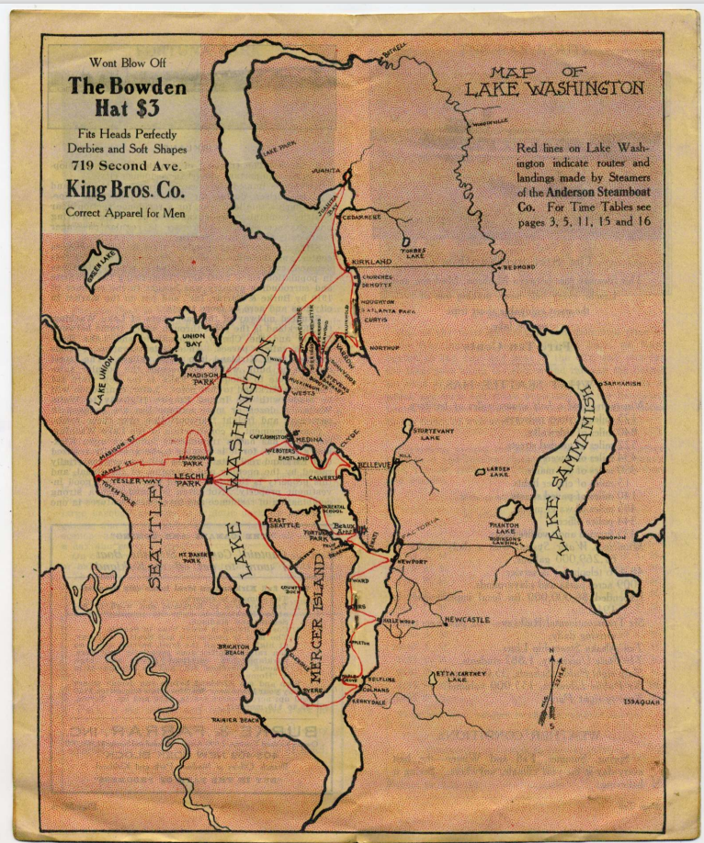
The areas of Finn Hill that had been clear cut were turned into fruit orchards and vegetable, chicken and dairy farms.
After Lake Washington was lowered by the Montlake Cut in 1916, Juanita Beach became a popular day and weekend resort for Seattle families, with cabins for rent. Small lots were plotted on Goat Hill overlooking Juanita Beach for privately owned cabins and camp sites.
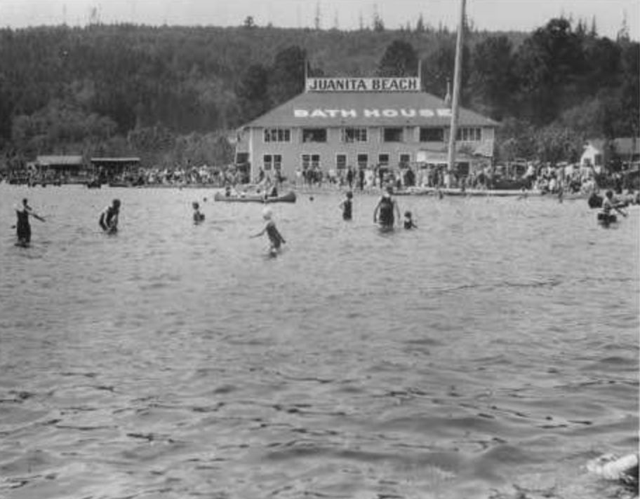
At the southern tip of Finn Hill, one of Seattle’s leading architects, Paul Kirk, designed a unique subdivision in the 1970s known as Finn Hill Meadows; it consists of 21 circular one-acre lots surrounded by common open space. During or shortly after World War II, an anti-aircraft battalion was stationed atop Finn Hill, and photographs suggest it may have been located on the Finn Hill meadows.
The Inglewood neighborhood at the top of Finn Hill was first platted and named by L.A. Wold in 1888. A small airstrip was later laid out on the site of what is now the Inglewood shopping center.
O.O. Denny Park, located on Lake Washington midway between Juanita Bay and St. Edward Park, is named for Orion Denny, son of Seattle founder Arthur Denny. The property was Orion’s country estate, Klahanie, and his widow willed it to the City of Seattle. The property was later used as a summer camp for youth before it was opened to the public as a park.
As Seattle was preparing for the 1962 World’s Fair, and the 10,000,000 people who came to to experience it, the Evergreen Point Floating Bridge was completed to connect Kirkland to Seattle. This led to a sharp increase in the population of communities on the Eastside, including Kirkland and Finn Hill.
Today, single-family residential homes have replaced farms and agriculture. Once located in unincorporated King County, Finn Hill was annexed by the City of Kirkland in 2011.
Want to dig a little deeper into Finn Hill’s history? Check out these sources:
- Kirkland Native History Document: kirkland-native-history-document.pdf (kirklandwa.gov)
- Juanita Beach cabins: Juanita Beach Park History (kirklandwa.gov)
- O.O. Denny park history: O. O. Denny Park - HistoryLink.org
- FHNA History Project – various blog posts about Finn Hill’s first European settlers: History Project | Finn Hill Neighborhood Alliance (finnhillalliance.org)
- King County Parcel Viewer – Base maps of King County that includes an aerial image of Finn Hill from 1936: King County Parcel Viewer
- Kirkland Heritage Society – an excellent source of information about Kirkland history: Kirkland Heritage Society
Finn Hill’s topography
The Puget Lobe of the great Cordilleran ice sheet advanced from Canada to Tacoma about 18,000 years ago, carving the Puget Sound, Lake Washington and Lake Sammamish from what was once a lowland plateau. As it retreated, the ice sheet left rows of hills composed of bedrock covered with glacial till. Finn Hill is one the hills that the ice sheet left as it withdrew to the north.
From its highest points in Big Finn Hill Park, Finn Hill drops steeply on its flanks to Lake Washington on the west and south and to Juanita Creek on the east.
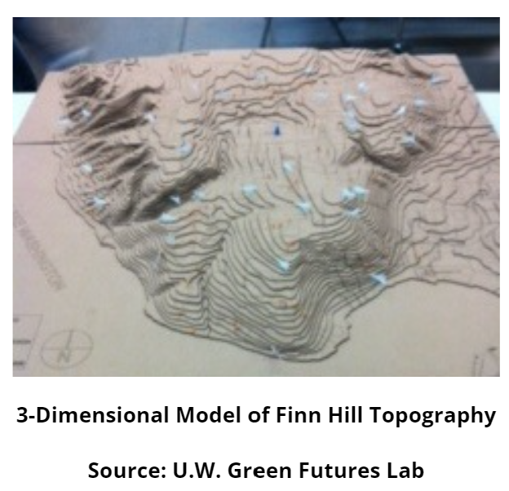
The hill has been carved by numerous creeks into deep gullies and is covered by four watersheds. The neighborhood’s principal stream, Denny Creek, flows from a beaver pond in Big Finn Hill Park, passes under Juanita Drive, and drops down to Lake Washington through a ravine that runs through O.O. Denny Park. The ravine has been the site of numerous landslides, recent and ancient. The depths of Lake Washington near the mouth of Denny Creek hold a petrified forest that washed out of the ravine many centuries ago. The creek once hosted salmon runs. Efforts to restore salmon in the creek are ongoing.
Creeks adjacent to Simonds Road and Goodwill Hill on the eastern side of Finn Hill feed Juanita Creek in the Juanita neighborhood. Juanita Creek empties into Juanita Bay at the eastern edge of the Finn Hill neighborhood. The stream still supports runs of Chinook salmon in the fall.
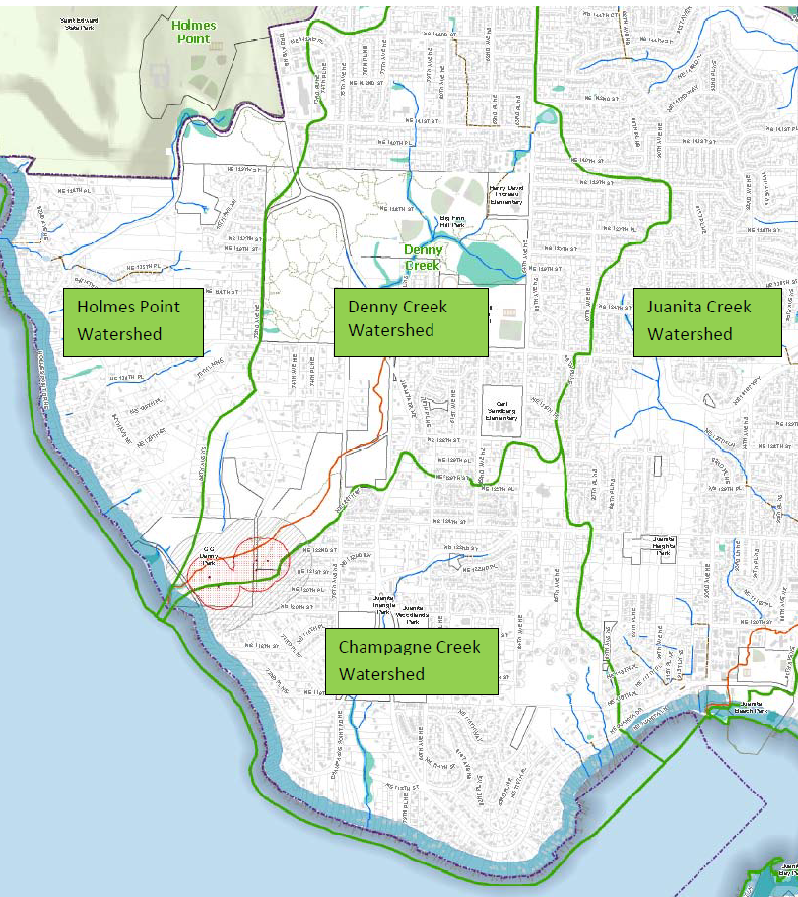

Finn Hill’s ecosystems
Finn Hill’s woodlands and watersheds have been severely degraded through deforestation and suburban development over the last 150 years. Nevertheless, the neighborhood is served by numerous large parks and most of its ravines are wooded; some of Finn Hill’s creeks and wetlands remain. Thanks to the preservation of these natural assets, Finn Hill retains some excellent examples of Puget Sound lowland native plant and tree ecosystems. Areas of Finn Hill are home to dense canopies of mature second growth Douglas fir, cedar, hemlock, madrone, big leaf maple, and vine maple. Beneath these trees are native shrubs and ground cover such as osoberry, Oregon grape, salal, and huckleberry.
Finn Hill also still hosts a significant variety of wildlife that have found ways to adapt to human encroachment. Black tailed deer, coyotes, bobcats, mountain beavers, squirrels, muskrats, racoons, beavers and otters live amongst us. Flying squirrels have been spotted in St. Edward Park to the immediate north of Big Finn Hill Park. Bald eagles and owls roost in Finn Hill’s Douglas firs, herons circle above Lake Washington along Finn Hill’s shoreline, ducks are ubiquitous, as are Canadian geese. Local residents, working with UW Faculty through the St. Edward Environmental Education & Research Center are tabulating evidence of wildlife activity throughout Finn Hill.
Want to learn more about Finn Hill’s flora and fauna? Check out the following:
- St. Edward Environmental Education & Research Center, a new center managed by University of Washington-Bothell: UW Bothell at the EERC in Saint Edward State Park (uwbeerc.org). In particular, stop by the Native Plant Learning Garden in St. Edward Park; the garden includes 30 common species, each tagged with QR codes linking to profiles of the plant’s natural history and indigenous uses. You can also look at the Native Plant Learning Garden’s webpages hosted by the EERC: https://uwbeerc.org/programs/plant-tour.
- Eastside Audubon Society: Eastside Audubon Society
Finn Hill’s parks and trails
Profiles of our neighborhood’s exceptional parks and trails will be added to this website in coming months. For now, you can learn more about our three largest parks by going to these sources:
- O.O. Denny Park: O.O. Denny Park – City of Kirkland (kirklandwa.gov)
- Big Finn Hill Park: Big Finn Hill - King County
- St. Edward State Park (to the immediate north of the Finn Hill neighborhood): Saint Edward State Park | Washington State Parks and Recreation Commission
Finn Hill’s environmental issues
Finn Hill’s history of logging, agricultural use, and suburban development has created a host of environmental issues that the Finn Hill Neighborhood Alliance is working to remedy. These challenges include:
- Surface water management: Roads, houses, yards and other impermeable surfaces lead to heavy runoff of rainwater during storms that scours creek channels, erodes hillsides, and pollutes streams and, ultimately, Lake Washington. Creek water quality reports produced by the City of Kirkland indicate that the water quality of Finn Hill’s principal streams is adversely affected by high levels of nitrogen and phosphorus. An even greater problem may be the extent of runoff immediately after heavy storms. Impervious surfaces on Finn Hill create flashy waterflows that wash away fish habitat and prevent ground water from seeping into the soil and flowing into streams at a steady rate, so that they don’t dry up during the summer. Kirkland recently upgraded its surface water management plan to address some of these issues.
- Slope stability: Covered with layers of glacial till, most of Finn Hill’s ravines and slopes present high risks of landslides and liquefaction. The City’s zoning code requires geotechnical studies before development occurs on particularly steep slopes. The Finn Hill Neighborhood Alliance commented on several aspects of the City’s recent revisions to its steep slope development regulations.
- Tree canopy: A healthy urban tree canopy is vital for clean air, cooler temperatures, surface water management, erosion control, and slope stability. Mature trees also support wildlife and enhance neighborhood character. Finn Hill’s tree canopy percentage was calculated in 2018 by the City of Kirkland at 50% - the highest of all Kirkland neighborhoods. Most of Finn Hill’s canopy cover is located in its parks and in ravines and in remaining large parcels that haven’t yet been developed to the capacity allowed by current zoning. As residential development – new construction and the addition of ADUs -- proceeds, Finn Hill’s tree cover will be reduced. The Finn Hill Neighborhood Alliance is working to mitigate canopy loss in three ways. First, it has advocated for stricter regulations governing tree removals and replacement planting associated with new development and road improvements. Second, it has advocated for more tree planting on public property. And, finally, it has focused on working with City and County officials to preserve woodlands through the expansion of the Finn Hill Green Loop.
More information about the issues outlined above can be found here:
- Surface water management and stormwater runoff: Storm & Surface Water – City of Kirkland (kirklandwa.gov)
- 2023 surface water management plan: Stormwater Policies and Regulations – City of Kirkland (kirklandwa.gov)
- Dashboards for the water quality of Finn Hill creeks: Kirkland Watersheds (arcgis.com)
- Landslide risks: City of Kirkland Landslide Map (kirklandwa.gov)
- Steep slope development regulations: KZC Chapter 85 – CRITICAL AREAS: GEOLOGICALLY HAZARDOUS AREAS (codepublishing.com)
- 2018 tree canopy survey: final-2018-utc-report.pdf (kirklandwa.gov)
- Urban forest management plan: UFMPJuly2013_FINAL_DRAFT_08212013 (kirklandwa.gov)
- Citywide tree code amendments: Tree Code Amendments – City of Kirkland (kirklandwa.gov)
- Holmes Point overlay code (special tree retention regulations for Holmes Point): Holmes Point Overlay - Code Update – City of Kirkland (kirklandwa.gov)
How to help
- Wildlife monitoring: We can support our remaining local wildlife by learning what species remain on Finn Hill, how they are coping with urbanization, and they are using the greenspaces that we have preserved. Local residents are working with UW Bothell faculty through the St Edward Environmental Education and Research Center’s Northwest Wildlife Science Network are tabulating evidence of wildlife activity through a network of wildlife cameras throughout the neighborhood.
- Salmon restoration: The Denny Creek Neighborhood Alliance (now FHNA), working with King County, rehabilitated creek banks and removed a dam in an effort to promote the return of salmon to the creek. Salmon restoration efforts were hampered by flashy surface water flows resulting from development upstream. Those efforts are expected to resume in the near future under the guidance of UW Bothell faculty. You can learn and get involved in salmon monitoring and restoration efforts by joining King County’s Salmon Watchers: Salmon Watcher Program - King County
- Trail maintenance and reforestation:
  - The Green Kirkland Partnership hosts regular work parties in the city’s parks including O.O. Denny Park and Juanita Heights Park in Finn Hill plus in city-owned green spaces near Juanita Woodlands Park and near Goodwill Hill. You can volunteer for work parties and even qualify to be the steward of one these parks or green spaces.
  - FHNA works with King County to restore native vegetation and trails in Big Finn Hill Park and Juanita Woodlands Park, the two County parks in our neighborhood. Sign up [link] for our newsletters and email bulletins to get news about our restoration projects in these parks.

